WHY MSMEs MATTER
MSMEs are not a small part of the economy—they are the foundation.
- Contribute ~30% to India’s GDP
- Generate large-scale employment
- Account for ~45% of exports
Yet most MSMEs struggle with:
- Lack of awareness about schemes
- Difficulty accessing finance
- Compliance challenges
- Delayed payments and missed opportunities
What this really means is:
benefits exist—but they don’t reach the people who need them most.

OUR VISION

We are committed to empowering India's entrepreneurial spirit by bridging the gap between government schemes and grassroots-level businesses. At Shri Nanak Foundation, we believe that informed entrepreneurs are the foundation of a Viksit Bharat 2047. Through dedicated support, awareness programs, and on-ground assistance, we help small business owners, aspiring entrepreneurs, women entrepreneurs to unlock the full potential of MSME-related benefits and policies.

OUR MISSION
- Increase MSME awareness at the ground level
- Enable access to government schemes and finance
- Support compliance and formalization
- Build long-term relationships with entrepreneurs
Active since April 2024, we focus on practical, on-ground impact—not just advisory.

OUR CORE SUPPORT AREAS
We don’t just inform—we help businesses take action.

1. Registration & Compliance
- Udyam Registration
- GeM Portal Registration
- DSC & PAN Assistance
- MSME ODR Filing (Delayed Payments)

2. Loan & Scheme Guidance
- PMEGP
- Mudra Loans
- Credit-linked subsidy schemes
- Documentation & eligibility support

3. Business Consultation
- One-to-one problem solving
- Scheme mapping based on business type
- Growth and compliance strategy

MSME AWARENESS CAMPS
We regularly conduct free on-ground MSME camps across industrial areas.
These camps are designed to be practical and interactive—not theoretical.
What happens in these camps:
- Live explanation of schemes
- Real business case discussions
- Open Q&A sessions
- Direct consultation with MSME owners

KEY CAMPS & EVENTS

Jhilmil Industrial Area MSME Awareness Camp
- Location: Jhilmil Friends Colony CETP Society, B Block, Delhi
- Date: April 4
⏰ Time: 3:00 PM – 5:00 PM
Objective:
- To create awareness about MSME schemes and formalization benefits among local industrial units
Key Activities:
- Detailed explanation of MSME registration and government schemes
- Step-by-step guidance on how to avail benefits
- Live Q&A session with business owners
- On-ground identification of eligible MSMEs
Special Highlights:
- Presence of Chief Guest Sanjay GoyalJi
- Active participation from industrial area members
- Focus on resolving real business challenges
Impact:
- Helped participants understand practical implementation of schemes
- Increased clarity on eligibility and documentation
- Encouraged MSMEs to initiate registration and compliance
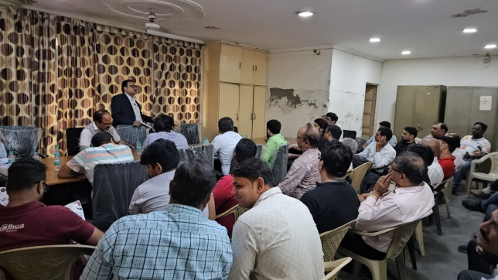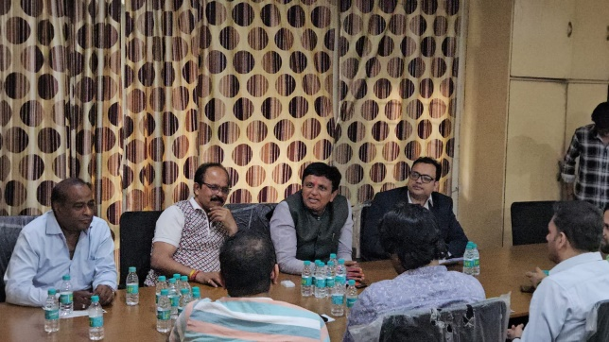

2. Sahibabad MSME Awareness Camp
- Location: Steel Pipe Distributors Association Bhawan, Sahibabad
- Date: April 16
⏰ Time: 3:00 PM – 4:00 PM
Objective:
- To provide direct consultation and scheme awareness to traders and manufacturers
Key Activities:
- One-to-one interaction with MSME owners
- Personalized guidance on loan schemes and subsidies
- Distribution of informational materials
- Clarification of documentation and process-related doubts
Special Highlights:
- Supported by ShriTarunAggarwal
- Focused consultation-based format (not just seminar)
- Strong engagement from association members
Impact:
- Immediate resolution of business queries
- Helped businesses identify suitable schemes
- Built trust for further advisory and support
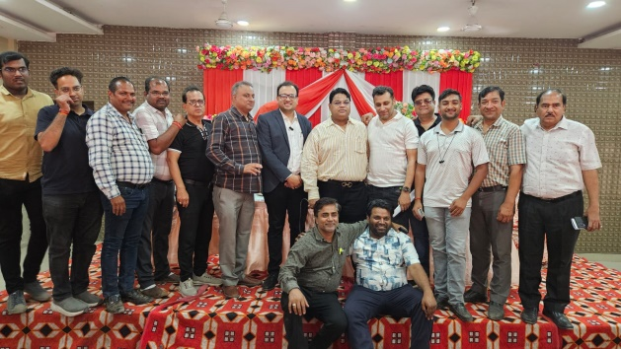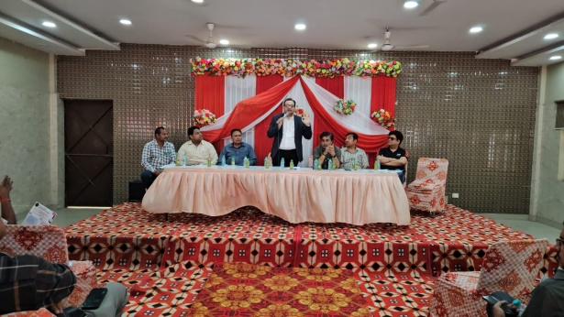
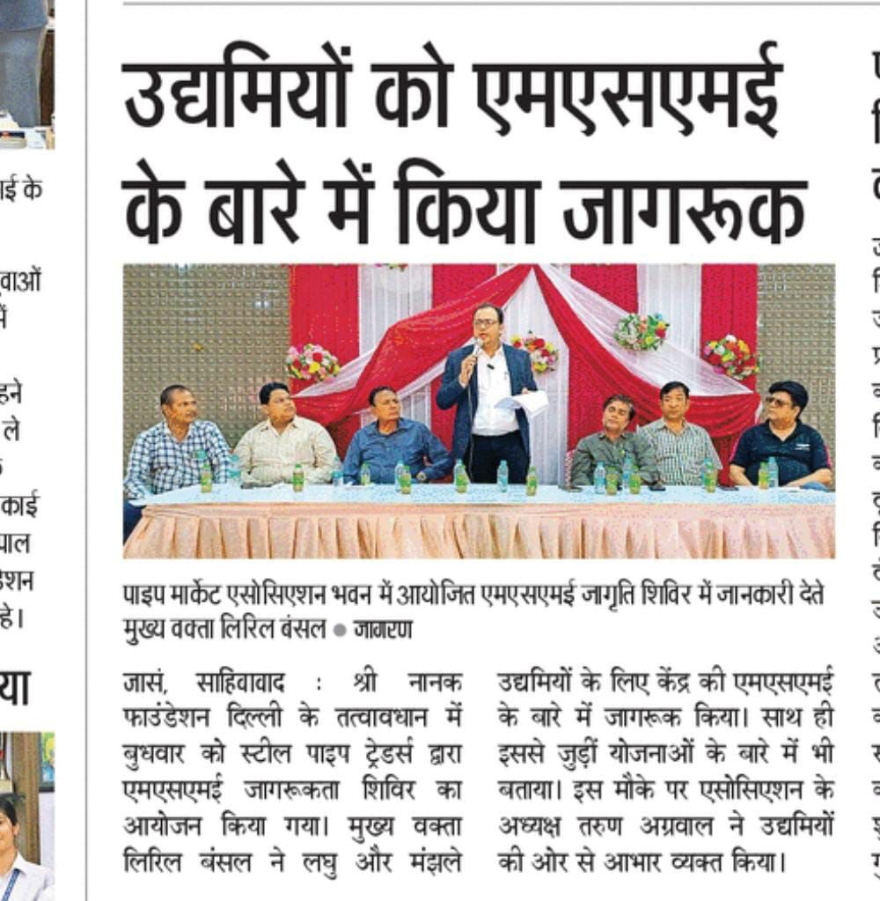

3. Shatabdi Varsh Samaroh MSME Camp
- Location: Friends Colony Industrial Area, Shahdara
- Date: December 15
Objective:
- To conduct large-scale MSME awareness during a major industrial gathering
Key Activities:
- Awareness sessions on MSME schemes and compliance
- Interaction with industrialists and association members
- Promotion of formalization and structured growth
Special Highlights:
- Conducted during a significant industrial event
- Recognition and appreciation for social contribution
- Strong networking with industrial stakeholders
Impact:
- Expanded outreach to a larger MSME audience
- Strengthened presence in industrial associations
- Increased awareness about government support systems
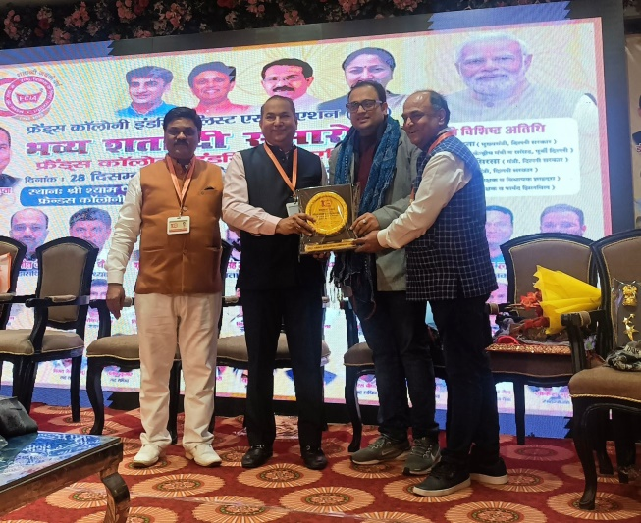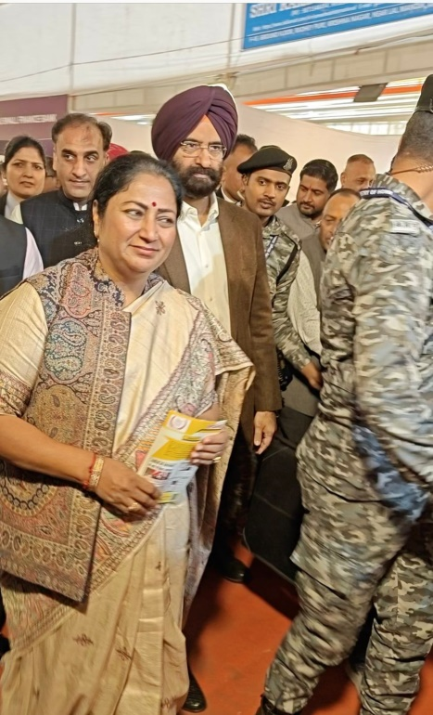
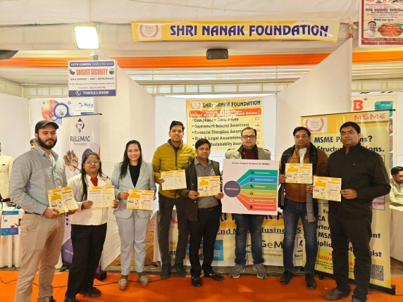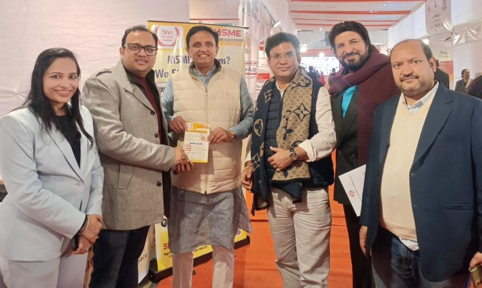
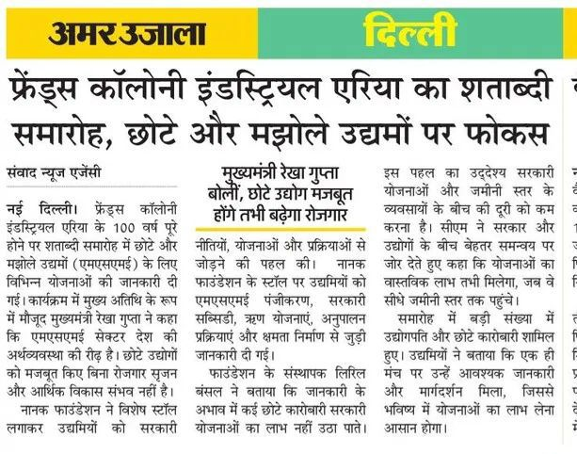

4. MSME WEEK 2025 – SPECIAL INITIATIVE
- Location: Multiple Touchpoints / On-Ground & Office Support
- Date: June 26 – June 30, 2025
Objective:
- To provide end-to-end MSME support through a dedicated awareness and service drive
Key Activities:
- Free Udyam Registration for new and existing businesses
- GeM Portal onboarding assistance
- Samadhaan filing support for delayed payments
- Loan consultation (PMEGP, Mudra, subsidy schemes)
- Documentation and compliance assistance
Special Highlights:
- Completely free support initiative
- Daily focused consultations
- Hands-on execution support (not just guidance)
Impact:
- Helped MSMEs resolve payment issues
- Enabled access to government marketplaces (GeM)
- Improved compliance and formal registration levels
- Increased participation in government schemes

MEDIA COVERAGE & RECOGNITION
Our initiatives have been recognized at multiple forums, including:
- Appreciation during Shatabdi Varsh Samaroh
- Acknowledgment for MSME awareness and social contribution
We continue to collaborate with industry associations and explore partnerships with PSUs and CSR initiatives to expand our reach.

